CROSS PLAINS INDEPENDENT SCHOOL DISTRICT
700 NORTH MAIN STREET
CROSS PLAINS, TEXAS 76443

NOTICE OF MEETING --- BOARD OF TRUSTEES
CROSS PLAINS INDEPENDENT SCHOOL DISTRICT

A Special Meeting (Board Training) of the Board of Trustees of the Cross Plains Independent School District will be held on Thursday, May 13, 2021, beginning at 5:30 PM, in the Cross Plains ISD Board Room. The subjects to be discussed or considered upon which any formal action may be taken are as follows:

SPECIAL MEETING

No formal action will be taken.

CLOSED MEETING: Adjournment to closed meeting pursuant to Sections 551.071 (consultation with attorney to seek and receive legal advice); 551.072 (discuss the purchase, exchange, lease or value of real property); Section 551.073 – (negotiating contracts for prospective gifts or donations); Section 551.074 - (consider the appointment, employment, evaluation, reassignment, duties, discipline, non-renewal or dismissal of a public officer or employee, or to hear complaints or charges against a public officer or employee); Section 551.076 (consider the deployment, or specific occasions for implementation, of security personnel and devices); Section 551.082 – (discussing or deliberating the discipline of a public school child or children, or a complaint or charge is brought against an employee of the school district by another employee); Section 551.0821 – (deliberating in a matter regarding a public school student if personally identifiable information about the student will necessarily be revealed by the deliberation); Section 551.083 (considering the standards, guidelines, terms or conditions the Board will follow, or instruct its representatives to follow, in consultation with representatives of employee groups in connection with consultation agreements).
RECONVENE INTO OPEN SESSION: Upon Conclusion of Closed Meeting
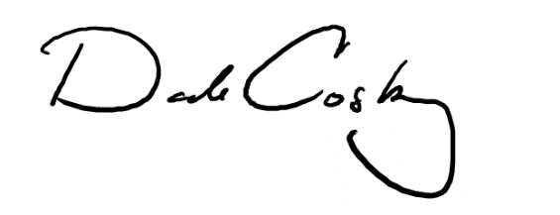
This notice was posted in compliance with the Open Meetings Act on May 7, 2021 at 3:45 PM.

________________________________
For the Board of Trustees

